📄 TALOSEC INCIDENT RESPONSE REPORT

Incident Identification
- Organization: Talosec
- Case Tracking Code: CORD-202512-AliRayyan-001
- Incident Type:
  - SSH Brute Force Attack
  - Network Port Scanning (Reconnaissance)
- Incident Status: Mitigation Pending – Admin
- Reported By: SOC Analyst Intern
- SOC Group Leader: Nasradin
- Analysis Period: Last 24 Hours
- Affected Asset: server02

1. Executive Summary
During routine SOC monitoring, two separate malicious activities were detected targeting server02.
The first activity consisted of a high-volume automated SSH brute-force attack aimed at credential compromise.
The second activity involved network reconnaissance through port scanning, indicating an attempt to enumerate exposed services.
Both activities originated from distinct external IP addresses, suggesting separate threat actors with different objectives.
No successful compromise was identified during the investigation window.

2. Incident Description
The investigation identified repeated unauthorized access attempts against the SSH service, as well as low-volume probing of multiple destination ports. These activities represent different stages of the attack lifecycle: direct access attempts and pre-attack reconnaissance.

3. Section A – Targeted SSH Brute Force Attack
Detection Details
- Source IP Address: 220.205.123.57
- Total Alerts: 263
- Wazuh Rule Triggered: 5710 – SSH Attempt to Login Using Non-Existent User
- Attack Pattern: Single, high-intensity alert spike
Analysis
The activity shows characteristics of an automated credential-guessing attack, where a large number of authentication attempts were generated in a short time frame. The attacker targeted only the SSH service, indicating an intent to gain immediate unauthorized access.
This behavior is consistent with widely used attack tools such as:
- Hydra
- Nmap SSH brute-force modules
- Similar automated password-guessing frameworks
Conclusion
This activity is classified as a High-Volume Automated SSH Brute-Force Attack, targeting the SSH service for rapid credential compromise.

4. Section B – Network Port Scanning (Reconnaissance)
Detection Details
- Source IP Address: 66.19.240.142, 20.192.21.54
- Total Alerts: 49,15=64
- Distinct Destination Ports Accessed: 13+5=18
- Attempts per Port: 2 (uniform distribution)
Analysis
The low and evenly distributed access across multiple destination ports is indicative of network reconnaissance, not brute-force behavior. The attacker systematically probed several ports to identify active services and potential vulnerabilities.
This pattern is consistent with reconnaissance tools such as:
- Nmap SYN Scan
- Nmap TCP Connect Scan
Such scanning activity is commonly observed prior to targeted exploitation attempts.
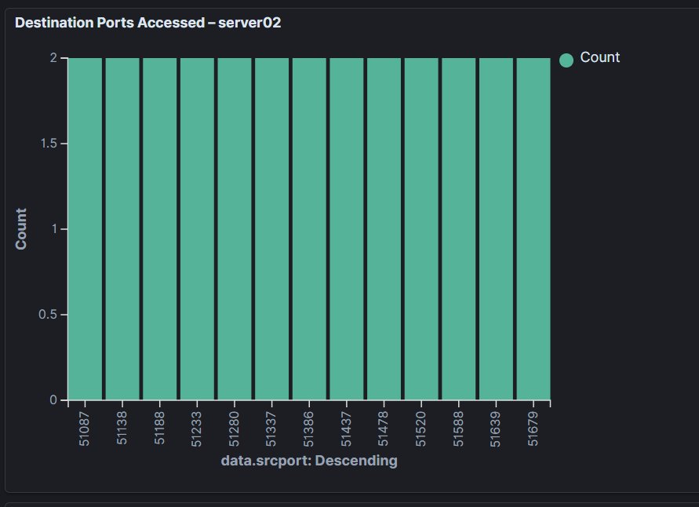
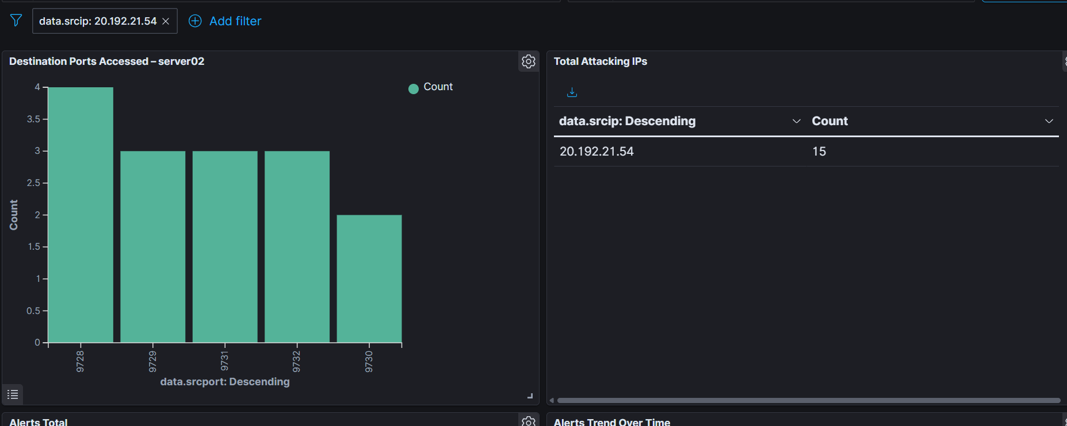
Conclusion
This activity is classified as Definitive Network Port Scanning (Reconnaissance), representing an attempt to map the server’s exposed attack surface.

5. Overall Incident Assessment
The investigation confirms the presence of two distinct malicious activities:
- One attacker focused on direct SSH service compromise via brute-force credential guessing.
- A second attacker conducted network reconnaissance, scanning multiple ports to enumerate available services.
Overall Summary Statement
“The server experienced both targeted SSH brute-force and network port scanning activity. While one attacker focused solely on rapid credential guessing against the SSH service, a separate attacker engaged in network reconnaissance by scanning 13 distinct destination ports. This behavior clearly indicates an attempt to map the server’s exposed services and represents a preparatory phase for potential future attacks.”

6. Impact Assessment
- System Availability: Not impacted
- Data Confidentiality: No evidence of compromise
- Data Integrity: Preserved
- Overall Risk Level: Medium

7. Actions Taken
- Security alerts were reviewed and correlated using Wazuh SIEM.
- Dashboards were created to visualize:
  - SSH brute-force activity
  - Destination port access patterns
- Findings were escalated to the SOC Group Leader for mitigation approval.
- No direct configuration changes were applied by the SOC intern.

8. Recommendations
- Enable automated mitigation (e.g., firewall-drop or Fail2Ban) for repeated SSH brute-force attempts.
- Review firewall configurations and restrict unnecessary exposed ports.
- Continue enhanced monitoring for:
  - Successful authentication attempts
  - Privilege escalation
  - Follow-up exploitation activity
- Maintain ongoing dashboards for SSH and reconnaissance monitoring.

9. Incident Status
Current Status: Mitigation Pending – Admin
Mitigation actions are scheduled to be applied by an authorized administrator.

10. Closing Statement
This incident demonstrates active external threat activity against server02. While no compromise was observed, the combination of brute-force attempts and reconnaissance highlights the importance of proactive detection, containment, and hardening measures.

